***@br1ght.st4rk***

**Installation and User Instructions**

**RALPH**| **Say Hello to the Future**

A I assistant, for windows



GitHub: <https://github.com/JongBright>

Email: [taletehbright@gmail.com](mailto:taletehbright@gmail.com)

## Ralph elements

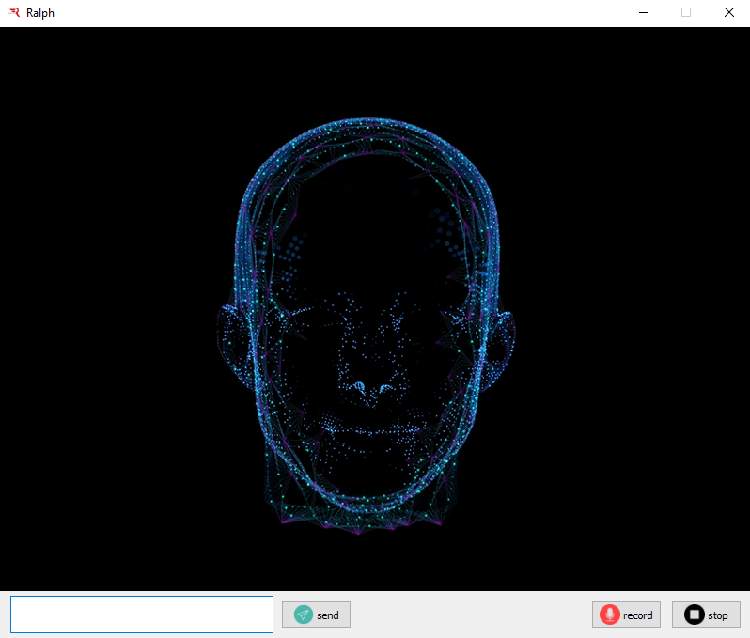

1. Animation (blue arrow)
2. Textbox (purple arrow)
3. Send Button (green arrow)
4. Record Button (orange arrow)
5. Stop Button (black arrow)
6. Minimize window button (yellow arrow)
7. Close window button (red arrow)

## Understanding the user interface of Ralph

a) Animation:

This is just an animation of Ralph’s face.

b) Textbox:

Sentences or commands can be typed in this textbox, whenever the user doesn’t want to speak.

c) Send Button:

After a message is typed in the textbox, clicking the Send button will send the message to Ralph.

d) Record Button:

Clicking the record button will allow Ralph to listen to the user using the computer microphone, whenever the user wants to send a message with speech.

e) Stop Button:

Clicking this button will mute the computer microphone. Ralph will stop listening to any speech as soon as the Stop button is clicked.

f) Minimize window button:

This simply minimizes Ralph window.

e) Close window button:

This simply closes Ralph window and stop the process.

# OPERATION/USE

## How to Use the Ralph

To use Ralph, you just need to tell him what to do. This can be done either by sending a text message through the textbox or sending a recorded message. To use the textbox, type the command and click the ‘send’ button. You may not need to be connected to the internet for this but some things may not function. To use speech mode, click on the ‘record’ button and speak. You need to be connected to the internet for this. You can mute the microphone anytime by clicking the ‘stop’ button.

## Ralph’s capabilities

You can speak freely with Ralph but in order to make Ralph actually understand what you want, there must be some keywords in the command you send. The following are examples, with the keywords in bold;

## 3.2.1 Simple Commands:

These commands do not require a lot of information. The following are examples;

|  |  |  |  |
| --- | --- | --- | --- |
| What you expect from Ralph | Examples of how your commands may look like | Keywords you must include | Ralph will: |
| Time | What is the **time** | Time | Tell you the time |
| Date | Tell me the **date** of today please | Date | Tell you the date |
| Location | Where are my currently **located** or  What is my current **location** | Location, Located | Tell you your location |
| Increase volume | **Add** my computer master **volume** | Action: increase, add  Target: volume | Increase your pc volume |
| Decrease volume | **Decreas**e the **volume** of my pc | Action: decrease, reduce  Target: volume | Decrease your pc volume |
| Increase brightness | **Increase** **brightness** | Action: increase, add  Target: brightness | Increase your pc brightness |
| Decrease volume | **Decreas**e my computer screen **brightness** | Action: decrease, reduce  Target: brightness | Decrease your pc brightness |
| Mute | **Mute** my pc | Mute | Mute your pc |
| Unmute | **Unmute** my machine | Unmute | Unmute your pc |
| Screenshot | **Screenshot** this page | Screenshot | Take a screenshot |
| Selfie | Take a **selfie** | Selfie | Take a selfie |
| Put on WIFI | **Turn on** my **WIFI** | Action: turn on, put on, switch on, connect, activate  Target: WIFI | Turn your WIFI on |
| Put off WIFI | **Put** my **WIFI off** | Action: turn off, put off, switch off, disconnect, deactivate  Target: WIFI | Turn your WIFI off |
| Conversion | **Convert** 200 euros to francs | Convert | Google search your desired conversion |
| Math’s problem | **Solve** 2 + 2 – 6 | Solve, compute, evaluate | Google search the results |
| Google search | **Search** on **google** | Google search | 1. Ask you what you want to search for on google…  2. If you respond, he will send your query to google |
| YouTube search | Search for something on **youtube** | Youtube | 1. Ask you what you want to search for on youtube…  2. If you respond, he will send your query to youtube |
| Play music | **Play** me a **song** | Action: play, open  Target: music, song, audio | 1. Ask for the author or title of the music…  2. If you respond, he will play the music if only he finds it on your computer |
| Play video | I want to **watch** a **movie** | Action: play, watch, open  Target: video, film, movie | 1. Ask for the author or title of the video …  2. If you respond, he will play the video if only he finds it on your computer |
| See your picture | **Open** my **picture** | Action: open, view, show  Target: picture, photo | 1. Ask for the name of the picture…  2. If you respond, he will open the picture, if only he finds it on your computer |
| Open any file | **Search** for a **file** | Action: search, open, find  Target: file | 1. Ask for the name of the file…  2. If you respond, he will open the file, if only he finds it on your computer |
| Open any program | **Run** an **application** for me | Action: open, run, start  Target: application, app, program | 1. Ask for the name of the program…  2. If you respond, he will open it, if only he finds it on your computer |
| Open any folder | **Open** a **folder** | Action: search, open, find  Target: folder | 1. Ask for the name of the folder…  2. If you respond, he will open the folder, if only he finds it on your computer |
| Open any website | **Open** a **website** | Action: open  Target: website, webpage | 1. Ask for the name of the website…  2. If you respond, he will open the site |
| Open any website or browser | **Open** a **browser** | Action: open  Target: browser | 1. Ask for the name of the browser…  2. If you respond, he will open the browser, if only he finds it on your computer |
| Close any music playing | **Stop** the **music** | Action: stop, close, terminate  Target: music, audio, song | Stop any music playing |
| Close any video playing | **Close** the **video** | Action: stop, close, terminate  Target: video, movie, film | Stop any video playing |
| Close any program running | **Terminate** the **app** running now | Action: stop, close, terminate  Target: program, application, app | 1. Ask for the name of the program…  2. If you respond, he will stop the program, if only the program was running |
| Delete any file or folder or music or video or picture | **Delete** a **file**/**folder** /**music**/**video**/**picture** | Action: delete, remove  Target: file/folder/music/video/picture | 1. Ask for the name of the file/folder/music/video/picture …  2. If you respond, he will delete the file/folder/music/video/picture, if only he finds it on your computer |
| Hard drive details | Tell me my hard **disk** specs | Disk, drive, storage | Tell you your hard disk details |
| Memory (RAM) details | Give me my computer **ram** details | Memory, random access memory, ram | Tell you your RAM details |
| Network details | Tell me my hard pc **network** specs | Network | Tell you your network details |
| Battery details | Give me details about my **battery** | Battery | Tell you your battery details |
| cpu details | Tell me my hard **cpu** specs | Cpu, central processing unit | Tell you your cpu details |
| gpu details | Tell me my hard **gpu** specs | gpu, central processing unit | Tell you your gpu details, if available |
| Computer specs | What are my **pc specs** | Specs | Tell you your computer’s properties |
| Empty recycle bin | Please **empty** my **recycle bin** | Action: empty  Target: recycle bin | Empty your computer’s recycle bin |
| Lock computer | **Lock** my **pc screen** | Action: lock  Target: computer, pc, machine, laptop, screen | Lock your computer screen |
| Log off computer | **Log off** my **machine** | Action: log off  Target: computer, pc, machine, laptop, screen | Log off your computer |
| Restart computer | **Restart** my **computer** | Action: restart  Target: computer, pc, machine, laptop, screen | Restart your computer |
| Shutdown computer | **Turn** my **pc off** | Action: turn off, put off, switch off, shutdown  Target: computer, pc, machine, laptop, screen | Shutdown your computer |

## 3.2.2 Complex commands

These commands require extra information. Also, NEVER include ‘**windows**’ in your sentences. See the following examples;

Setting reminders or alarms:

|  |  |
| --- | --- |
| Ways to set a reminder/alarm | Ralph will: |
| Set a reminder | 1. Ask for the time for the reminder  If a response is received from the user  2. Ask for the reminder message  If a response is received from the user  3. Set reminder |
| Set a reminder for 8:15 am | 1. Ask for the reminder message  If a response is received from the user  2. Set reminder |

Messaging a WhatsApp contact:

|  |  |
| --- | --- |
| Ways to set a reminder/alarm | Ralph will: |
| Send a message to a WhatsApp contact | 1. Ask for the phone number of the contact  If a response is received from the user  2. Ask for the message you want to send  If a response is received from the user  3. Send the message to the contact |
| Send a message to 237655443322 on WhatsApp | 1. Ask for the message you want to send  If a response is received from the user  2. Send the message to the contact |

Getting weather:

|  |  |
| --- | --- |
| Ways to set a reminder/alarm | Ralph will: |
| How is the weather | 1. Ask for the city whose weather details are required  If a response is received from the user  2. Give the weather details of the city |
| How is the weather of New York | Give the weather details of ‘New York’ |

Opening audios and videos:

|  |  |
| --- | --- |
| Ways to Play a music or video | Ralph will: |
| Play the music rockstar | Play ‘rockstar’ music, if only it finds it on your computer |
| I want to watch the movie titled money heist | Play ‘money heist’ video, if only it finds it on your computer |
| Play no new friends | Search for any music or video named ‘no new friends’ and play it, if only the music or video is in your computer |

Opening files, folders, programs, websites or browsers:

|  |  |
| --- | --- |
| Ways to open a file, folder, program, website or browser | Ralph will: |
| Open/search/find the file data.csv | Open ‘data.csv’ file, if it finds it on your computer |
| Open races.xlsx | Open ‘races.xlsx’ file, if it finds it on your computer |
| Open/search/find the folder with name test | Open ‘test’ folder, if it finds it on your computer |
| Open testing | Open ‘testing’ folder, if it finds it on your computer |
| Open/run/start code blocks program/app /application | Open ‘code blocks’ application, if it finds it on your computer |
| Open code blocks | Open ‘code blocks’ application, if it finds it on your computer |
| Open the website bing | Open ‘bing’ website |
| Open Instagram | Open ‘instagram’ website |
| Open chrome browser | Open ‘chrome’ browser, if it finds it on your computer |
| Open firefox | Open ‘firefox’ browser, if it finds it on your computer |

Closing programs or browsers:

|  |  |
| --- | --- |
| Ways to close a file, program or browser | Ralph will: |
| Close/stop/terminate the program /app/ application postman | Stop ‘postman’ application, if it is running on your computer |
| Close/stop/terminate postman | Stop ‘postman’ application, if it is running on your computer |
| Close/stop/terminate the firefox browser | Stop ‘firefox’ browser, if it is running on your computer |
| Close/stop/terminate firefox | Stop ‘firefox’ browser, if it is running on your computer |

Deleting audios, videos, pictures, files or folders:

|  |  |
| --- | --- |
| Ways to delete a music, video, picture, file or folder | Ralph will: |
| Delete/remove the audio/song/music alone | Delete ‘alone’ music, if only it finds it on your computer |
| Delete alone | Delete ‘alone’ music, if only it finds it on your computer |
| Delete/remove the film/video/movie justice | Delete ‘justice’ video, if only it finds it on your computer |
| Delete justice | Delete ‘justice’ video, if only it finds it on your computer |
| Delete/remove the picture/photo img | Delete ‘img’ picture, if only it finds it on your computer |
| Delete img | Delete ‘img’ picture, if only it finds it on your computer |
| Delete/remove data.rar file | Delete ‘data.rar’ file, if only it finds it on your computer |
| Delete data.rar | Delete ‘data.rar’ file, if only it finds it on your computer |
| Delete/remove the folder called test | Delete ‘test’ folder, if only it finds it on your computer |
| Delete test | Delete ‘test’ folder, if only it finds it on your computer |

## 3.2.3 Special commands

Direct Control:

The direct control functionality allows you to directly control your computer simply by telling ralph. You can tell ralph to press keys, edit text, type, etc.

The following are some examples, with the keywords in bold:

|  |  |  |
| --- | --- | --- |
| What you want | Example of how your command should look like | Ralph will: |
| Press any key on the keyboard | **press** shift | Press ‘shift’ key |
| Check the properties of the selected file | check **properties** | Open properties window of the selected file |
| Cycle through taskbar apps | **change taskbar app** | Cycle through taskbar apps |
| Show opened all windows | show **opened windows** | Display all opened windows |
| Close active window | **close** the active window | Close the window currently active |
| Open the shortcut menu | open **shortcut menu** | Open the shortcut menu of that window |
| Delete selected file | **delete** this file | Delete the selected file |
| Refresh | **refresh** my computer | Refresh the active window |
| Open quick link menu | open **quick link menu** | Open the computer quick link menu |
| Open action center | open the **action center** | Open the action center |
| Navigate to/from desktop | go to the **desktop** | Navigate to/from the desktop |
| Minimize all windows | **minimize** all windows | Minimize all active windows |
| Restore minimized windows | **restore** the **minimized windows** | Restore all minimized windows |
| Maximize a window | **maximize** this window | Maximize the active window |
| Open file explorer | open the **file explorer** | Open the computer file explorer |
| Open computer settings | open **pc /computer/machine settings** | Open computer settings window |
| Open connect settings | open **connect settings** | Open connect settings window |
| Open projector settings | open **projector settings** | Open projector settings window |
| Focus desktop search bar | open **windows search bar** | Focus on search bar |
| Take a snip/snippet/screenshot | take a **snip /screenshot** | Screenshot |
| Type text | **type/write** this is the message | Type ‘this is the message’ |
| Copy an item | **copy** this item | Copy the selected item |
| Select an item | **select** this item | Click on the item |
| Select a block of items | **select all** these items | Select all the items in the active window |
| Cut an item | **cut** this item | Cut the selected item |
| Paste a copied or cut item | **paste** it here | Paste the copied or cut item in the current directory |
| Undo an action | **Undo** this work | Undo the previous action |
| Redo an action | **redo** that action | Redo the previous action which you undid |
| Save changes | **save** these changes | Save any changes |
| Indent letter, text or block of text | **indent** | Indent |
| Unindent letter, text or block of text | **unindent** | Unindent |
| Rename an item | **rename** this file | Rename the selected item |
| Open the address bar | open **address bar** | Open the current window’s address bar |
| Focus on the explorer search bar | **search** the **explorer** | Focus on the file explorer search bar |
| Open clipboard | open **clipboard** | Open the clipboard |
| Show hidden icons | show the **hidden icons** | Open the hidden icons panel |
| Show task view | show me my **recent activity/task view** | Open task view |
| Create a new folder | create **new folder** | Create a new folder in the current directory |
| Open run | open **run** | Open ‘run’ |
| Open cmd | open **cmd/** **command prompt /command line** | Open command prompt |
| Open powershell | open **powershell** | Open windows powershell |

**Note:**

1 - When Ralph starts, it gathers your files paths and store in a database for easy reference. This is done the first time you open Ralph. If you have made changes to your computer after that, you can use the “**Update** paths” command, to update Ralph’s database.

### 2 - Ralph is NOT built for conversations, but to assist. However, you can talk to him or ask him questions and he will respond if he is able to but if he doesn’t understand, he will be silent.

### example:

Your question: ‘How are you’.

Ralph’s response: ‘I am doing great, thanks for asking’.